CCMN432 (310): Assignment # 5

Final Report

______________

[Hamza Malik](mailto:hamza.ejaz.malik@ryerson.ca)

501112545

Professor Dianne Nubla

Monday, Dec 19, 2022

**Executive Summary**

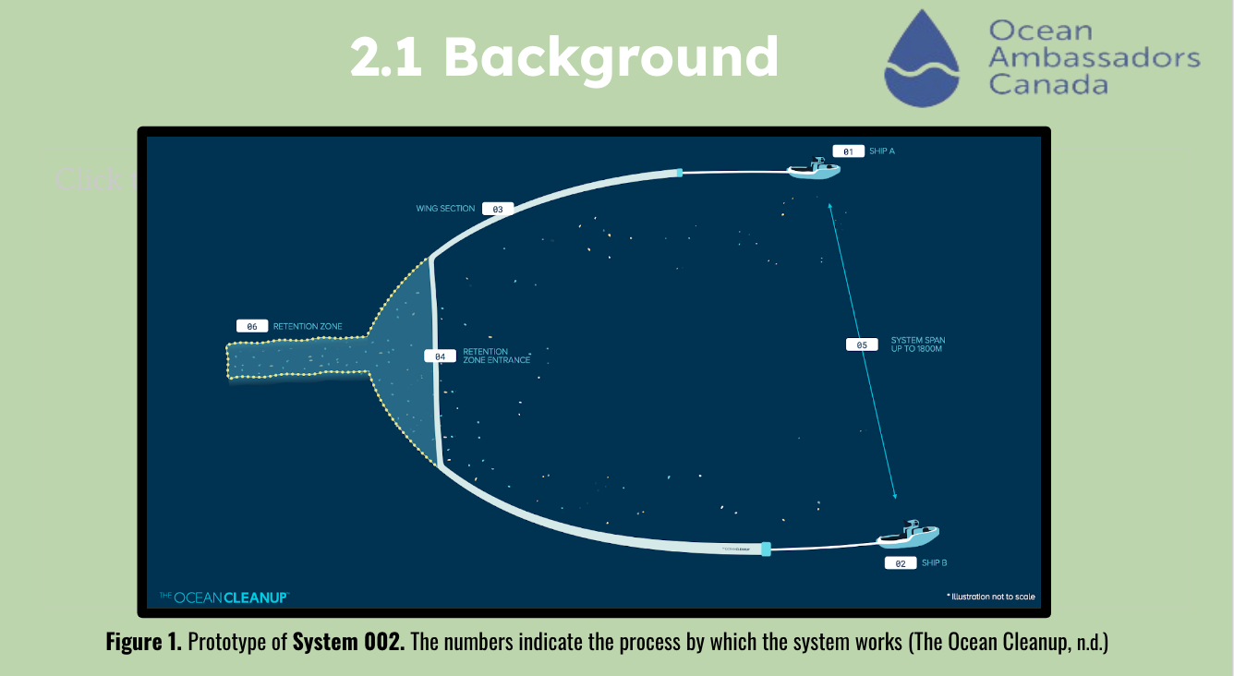

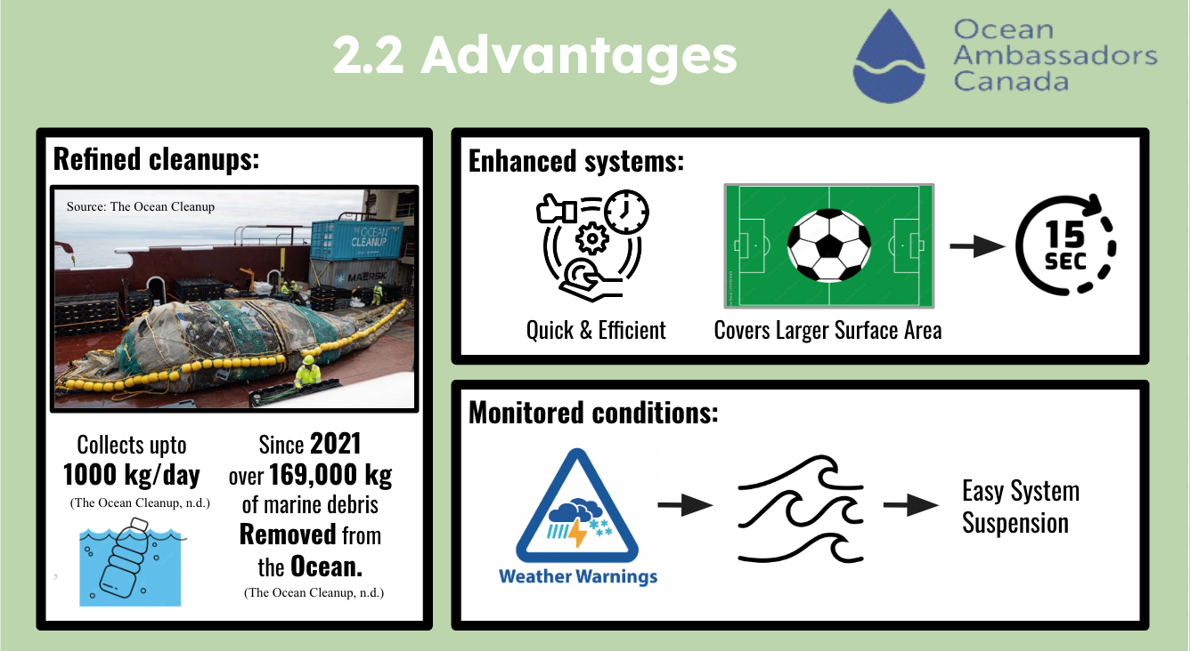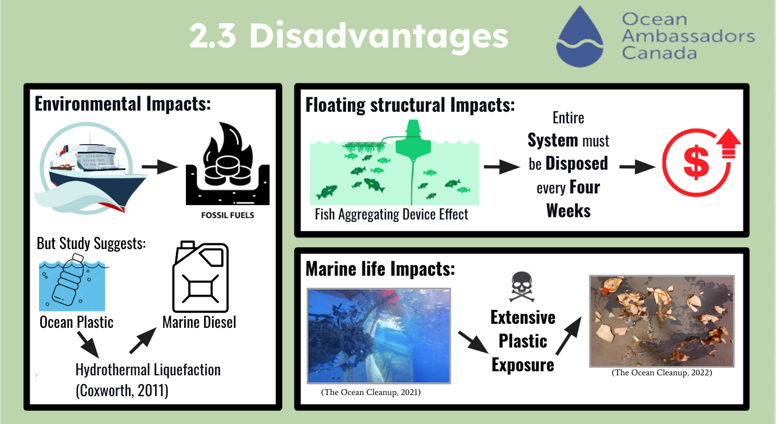

**Table of Contents**

Executive Summary……………………………………………….....……………….……. 01 - 02

1.0 Introduction……………..……………………………………………….……..…………… 04

2.0 Possible Solution…….………...………………...……………………………………….…. 05

2.1 Criteria #1 Background…….………...………………………..……………...…….. 05

2.2 Criteria #2 Advantages…….………...………………………………………….….. 05

2.3 Criteria #3 Disadvantages…….………...…………………………………….…….. 06

3.0 Conclusion…………….………………………………………………………..…………... 07

4.0 Recommendations…………..………..…………………………………………………..…. 07

References…………………………...…………………………………………………….. 08 - 09

**1.0 Introduction**

**Plastic Waste Accumulation in Great Pacific Garbage Patch**

Among the world's most prominent garbage patches, the Great Pacific Garbage Patch is one of the largest. A vast region extending from the western coast of North America to Japan is located in the Pacific Ocean (The Ocean Cleanup, 2021). Marine debris and plastics accumulate in this region of approximately 1.6 million square kilometres (Leal Filho, Hunt, & Kovaleva, 2021). Approximately 1.8 trillion pieces of plastic, microplastic, and marine debris accumulate in The Great Pacific Garbage Patch (National Library of Medicine, 2018).

As the Great Pacific Garbage Patch grows and expands, reducing and preventing waste movement into our oceans is urgent. Plastic pollution poses a significant threat to marine life, humans, and the environment. As a result of the word 'garbage patch,' images of floating trash islands are evoked. In reality, these garbage patches consist mainly of microplastics that are difficult to observe with the naked eye; satellite imaging is often unable to detect signs of large patches. As a result of plastics' ability to release and absorb pollutants, they pose additional risks, including photodegradation, which releases chemicals that can harm the environment (How Does Plastic End Up in the Ocean? n.d.).

* Animals: Garbage dumped into oceans can cause oxygen levels to become depleted, which can negatively impact marine life. This indigestible plastic can kill, choke, or mistake these creatures for food, significantly harming their health (Mckenzie, 2020).
* Humans: We humans consume fish and other sea animals that may have ingested toxic chemicals from plastics. Marine life can contain toxins such as lead, calcium, and mercury, which can be dangerous for humans (Andrews, 2021).
* The Environment: Many plastic pollutants are not biodegradable, meaning they cannot decompose, which is why our oceans are so polluted (Evers, 2022). As plastic breaks down, it produces microplastic bits, which settle at the bottom or become suspended in the water column (Schoell, 2019).

This report aims to address the issue of the planet's growing marine pollution through solutions to reduce the amount of waste that finds its way into the Great Pacific Garbage Patch.

**2.0 Implementing System 002**

The following section outlines the workings of the solution, its potential benefits, drawbacks, and methods for enhancing its environmental sustainability.

**2.1 Criteria #1: Background**

A detailed overview of the functional specifications with respect to System 002 has been provided as follows:

The Ocean Cleanup presented System 002, also known as Jenny, in July 2021, as their first large-scale cleanup solution. It consists of two vessels slowly dragging a tensioned artificial coastline on ocean surfaces rich in plastic waste along the ocean's surface (The Ocean Cleanup, n.d.). The artificial coastline scales three meters below the ocean's surface, which allows floating plastic pieces and marine debris to get caught in the strands of this artificial coastline (CNET, 2021). During the course of the water flowing through System 002, the large opening in the center of the system facilitates the passage of fish and other marine life, which makes it easier for fish and different marine life to pass through the system (CNET, 2021). Debris moves toward the system's center with the flow, collecting in an area called the retention zone (Designboom, 2021). After the retention zone has reached its maximum capacity, the debris is unloaded and transported to waste-sorting facilities, where it is sorted and recycled to the extent possible (Designboom, 2021).

**2.2 Criteria #2: Advantages**

The following table describes System 002's advantages in the categories of benefits:

| **Refined cleanups:** | **Enhanced systems:** | **Monitored conditions:** |
| --- | --- | --- |
| The Ocean Cleanup System 002, large-scale cleanups can be facilitated without affecting marine life since it collects up to 1000 kilos of marine debris daily (The Ocean Cleanup, n.d.). This system has removed 169,565 kilograms of marine debris from nearly 4,453 square kilometres since July 2021 (The Ocean Cleanup, n.d.). | With System 002, operators can move more efficiently and quickly to clean dense areas, reducing plastic removal costs and covering a larger surface area. Menezes reports that the technology can clean an area the size of a soccer pitch every 15 seconds (Menezes, 2021). | To ensure that the system can adapt to weather forecasts and reduce the load in the event of rough seas, it is continually assessed (Designboom, 2021). During a severe storm, the system can easily be suspended and deposited on a vessel (The Ocean Cleanup, n.d.). |

Essentially, the system enhances the quality of water bodies for marine life and other organisms by removing marine debris and plastic over large surface areas.

**2.3 Criteria #3: Disadvantages**

The following are some of the disadvantages associated with System 002 that can be summarized in the following manner:

| **Environmental Impacts:** | System 002 effectively reduces marine debris and floating plastic fragments but requires extensive fueling, leading to extensive fossil fuel consumption and shore excursions (Lavars, 2021). A recent study has demonstrated that ocean plastic fragments can be liquefied into marine diesel through hydrothermal liquefaction (Coxworth, 2011), which occurs at extremely high temperatures (Lavars, 2021). |
| --- | --- |
| **Floating structural Impacts:** | Floating structures can cause a fish aggregating device effect where small fish are attracted to marine debris like ropes (NOAA FISHERIES, 2017), which is why it's essential to empty the retention zone twice a week and dispose of the entire system after four weeks to prevent harming marine life (The Ocean Cleanup, n.d.). A replacement system must be implemented to maintain ecosystem balance, which increases cleanup costs. |
| **Marine life Impacts:** | Although most marine life can swim beneath the retention zone, some creatures, like turtles, can get stuck between the inner and outer meshes and become harmed by extensive plastic exposure (The Ocean Cleanup, 2022). |

**3.0 Conclusion**

After analyzing the great pacific garbage patch concept and a potential solution outlining the background, advantages and disadvantages, system 002 would be the ideal solution. A total area of 1.6 million square kilometres is covered by the great Pacific garbage patch (Leal Filho, Hunt, & Kovaleva, 2021), which contains over 1.8 trillion pieces of plastic (National Library of Medicine, 2018). Plastic accumulation in the ocean can be reduced by using large-scale cleanup technologies. As a possible solution to this crisis, this report proposes system 002, which has both advantages and disadvantages in creating an environment that is more environmentally friendly and sustainable.

**4.0 Recommendations**

The following measures should be taken to maximize the benefits of system 002:

1. **Faster Alternative to help clean up waste quickly.**

With 1.8 trillion plastic pieces and more being dumped yearly in The Great Pacific Garbage Patch, system 002 may reduce the amount of plastic waste in the environment (National Library of Medicine, 2018). Knowing that this technology will be able to clean an area of the ocean the size of a soccer field within 15 seconds (Menezes, 2021), the ocean cleanup aims to clean 90% of Ocean plastic by 2040 (The Ocean Cleanup. (n.d.)).

1. **Hold multiple systems and Convert Ocean Plastic into Marine Diesel on deck.**

Using hydrothermal liquefaction (Coxworth, 2011), ocean plastic fragments can be liquefied into oils at extremely high temperatures. Transforming ocean plastic into Marine Diesel and having multiple systems002 on deck will reduce travel time and environmental impact (Lavars, 2021).

1. **Extra Surveillance**

Despite the possibility of marine life getting caught in the retention zone, cameras and crew members will be on patrol (The Ocean Cleanup, 2022). It is intended that by doing so, there will be no additional risks to marine life or any organisms residing in the ocean (The Ocean Cleanup, 2022).

**References**

CNET. (2021, November 2). The Ocean Cleanup begins cleaning the Great Pacific Garbage Patch.

<https://www.youtube.com/watch?v=tLcnJEMnlTs>

Coxworth, B. (2011, July 5). The plastic2Oil process turns plastic waste into fuel. New Atlas. <https://newatlas.com/plastic2oil-converts-plastic-to-fuel/19108/?itm_source=newatlas&itm_medium=article-body>

Designboom. (2021, October 12). the ocean cleanup tests its massive system 002 to great success.

Designboom | Architecture & Design Magazine.

<https://www.designboom.com/technology/the-ocean-cleanup-system-002-test-10-12-2021/>

Haro, A. (2021, November 3). The Ocean Cleanup Crew Just Proved That System 002 Works. The Inertia. <https://www.theinertia.com/environment/the-ocean-cleanup-crew-just-proved-that-system-002-two-works/>

Lavars, N. (2021, November 3). Can ocean cleanup boats power themselves by turning plastic into fuel? New Atlas. <https://newatlas.com/environment/ocean-cleanup-boats-plastic-blue-diesel-fuel/>

National Library of Medicine. (2018, March 18). The Great Pacific Garbage Patch counts. <https://www.ncbi.nlm.nih.gov/search/research-news/4120/#:~:text=The%20Great%20Pacific%20Garbage%20Patch%20counts%201.8%20trillion%20pieces%20of>

Newton, M. (2022, January 31). Is the Ocean Cleanup Back on Track? New System Starts Cleaning Up the Pacific Trash Patch. Digital for Good | RESET.ORG. <https://en.reset.org/is-the-ocean-cleanup-back-on-track-new-system-starts-cleaning-up-the-pacific-trash-patch/>

NOAA FISHERIES. (2017, November 30). Fishing Gear: Fish Aggregating Devices | NOAA Fisheries. <https://www.fisheries.noaa.gov/national/bycatch/fishing-gear-fish-aggregating-devices#:~:text=Fish%20aggregating%20device>.

Plastic pollution coalition. (2022, May 16). What Really Happens To Your Plastic “Recycling.” <https://www.plasticpollutioncoalition.org/blog/2022/5/16/what-really-happens-to-your-plastic-recycling#:~:text=From%20a%20recycling%20bin%2C%20plastics>

The Ocean Cleanup. (2022, January 10). System 002: Mid-Term Evaluation • Updates • The Ocean Cleanup.

<https://theoceancleanup.com/updates/system-002-mid-term-evaluation/>

The Ocean Cleanup. (n.d.). System 002 • Milestones • The Ocean Cleanup. The Ocean Cleanup. Retrieved October 31, 2022, from <https://theoceancleanup.com/milestones/system-002/#:~:text=System%20002%20is%20our%20first>

The Ocean Cleanup. (n.d.). Will the systems have a Fish Aggregating Device (FAD) effect? • FAQs • The Ocean Cleanup. The Ocean Cleanup. Retrieved November 23, 2022, from <https://theoceancleanup.com/faq/will-the-systems-have-a-fish-aggregating-device-fad-effect/>